**Q3. Configure static IP addresses, modify MAC addresses, and verify network connectivity using ping and ifconfig commands.**

**WINDOWS:**

**Simple network setup:**

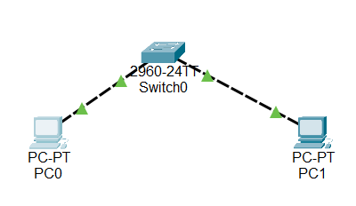

**Before changing the MAC address of PC’s:**

**PC 0**

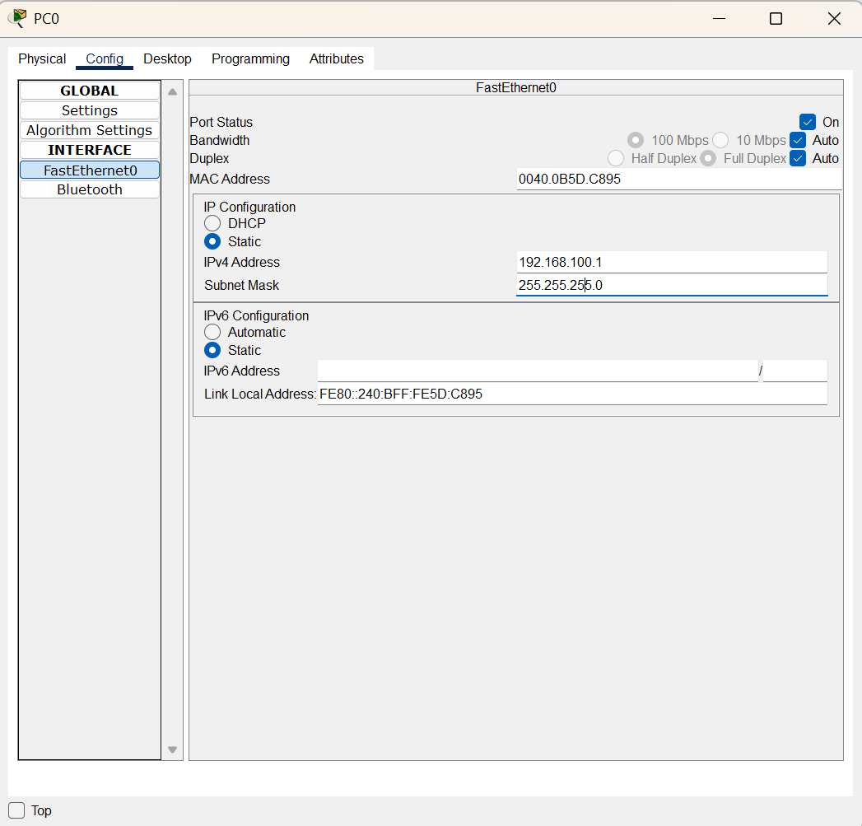

**PC 1**

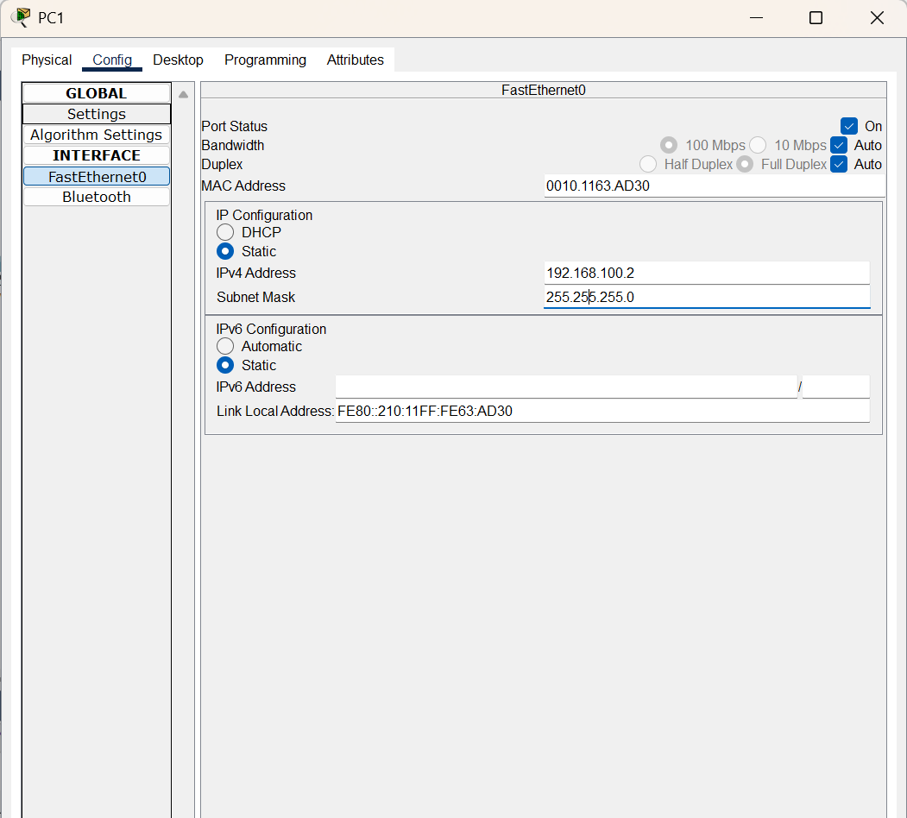

**After changing the MAC address of PC’s:**

**PC 0**

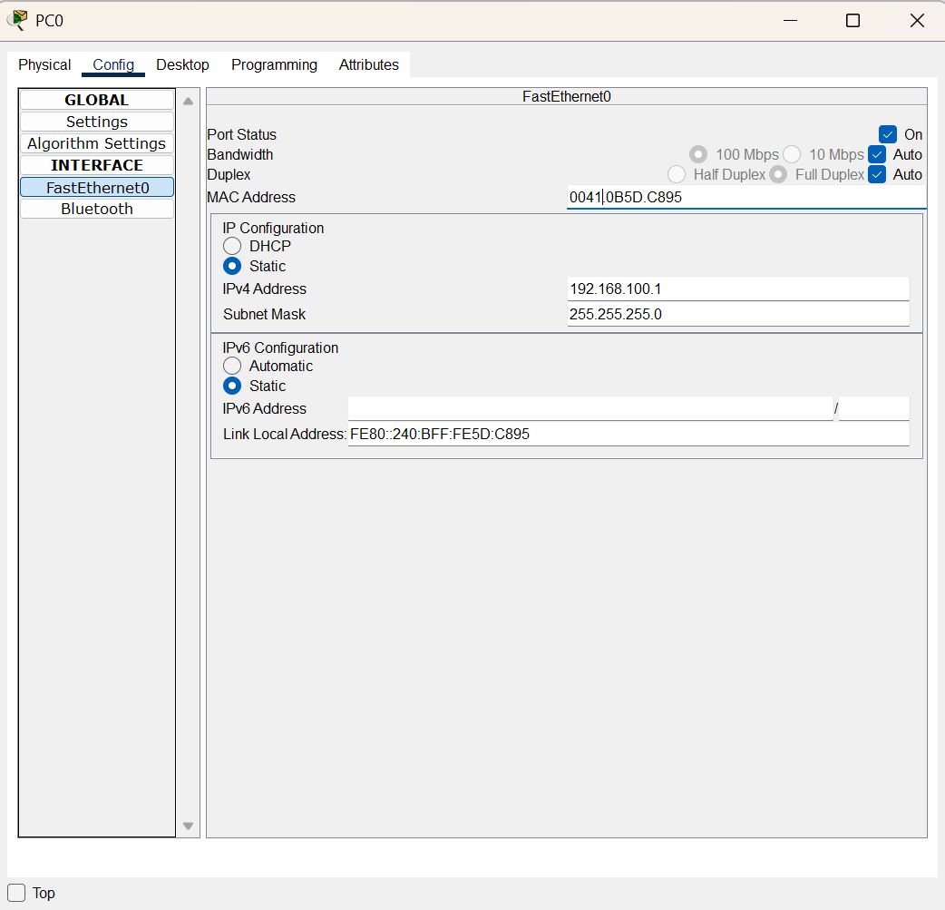

**PC 1**

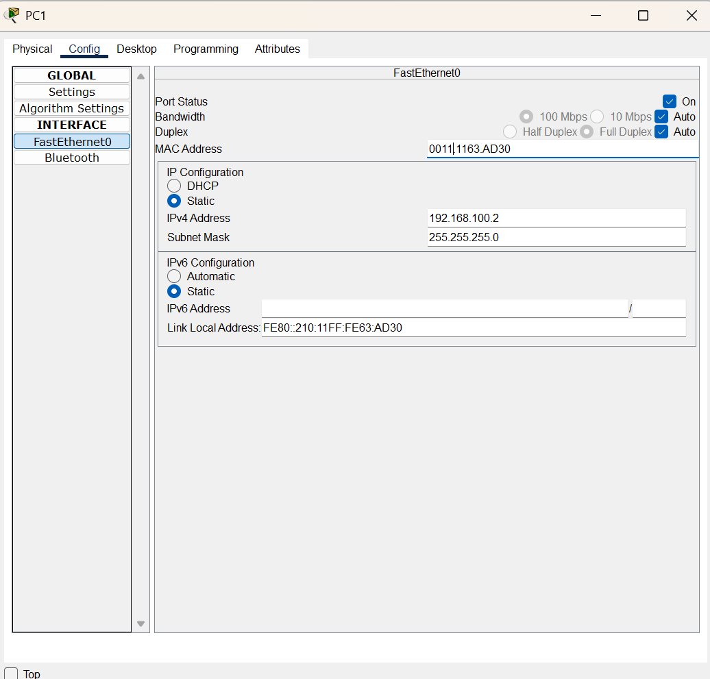

**Switch MAC address table**

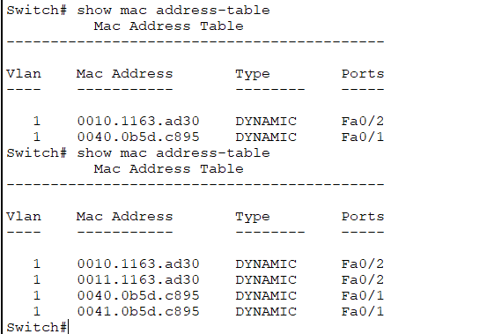

After changing MAC

Before changing MAC

**Ping commands to verify network connectivity:**

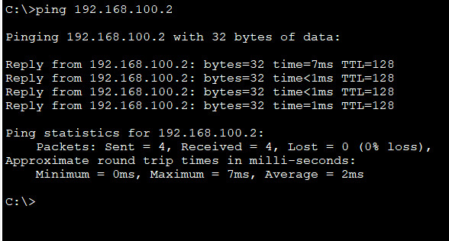

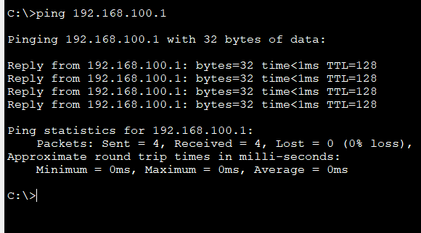

**ipconfig /all command :**

**PC 0:**

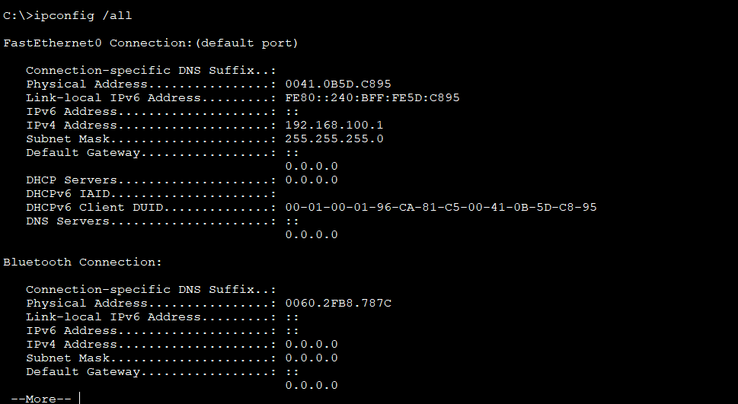

**PC 1:**

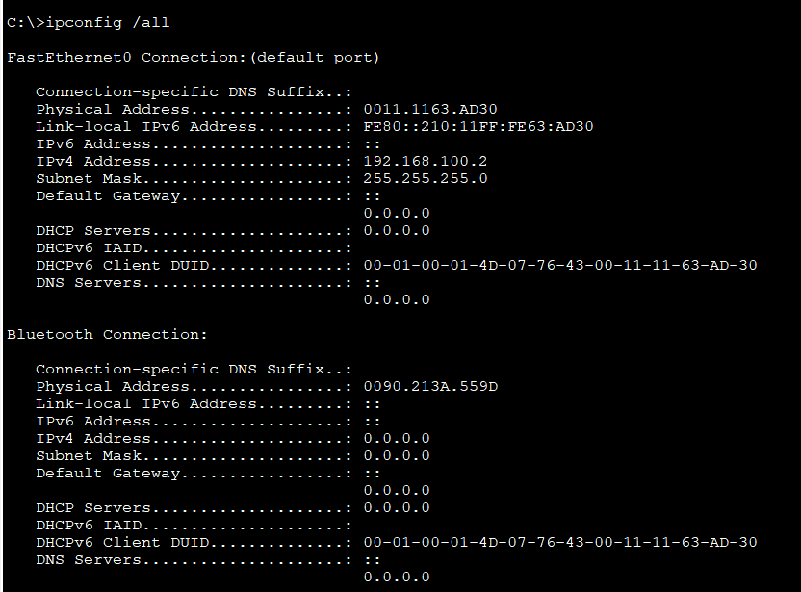

**Brief description of the ip interfaces:**

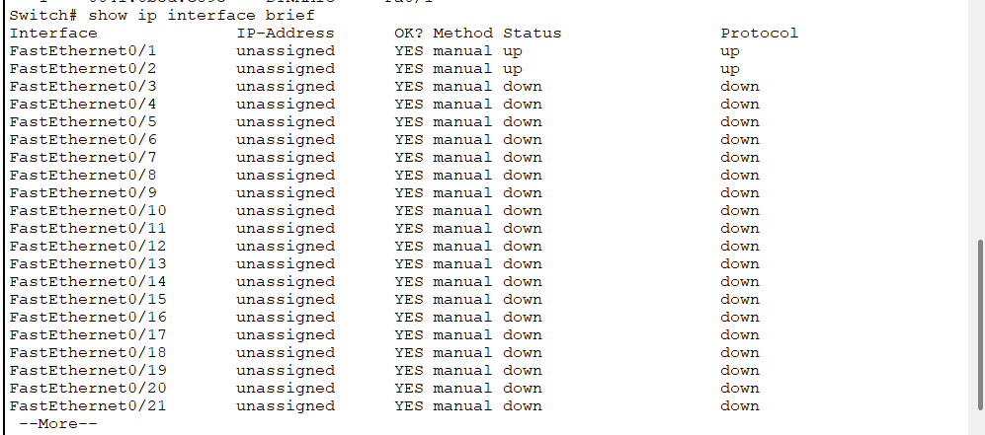

**LINUX:**

**Using ifconfig cmd to check the interfaces:**

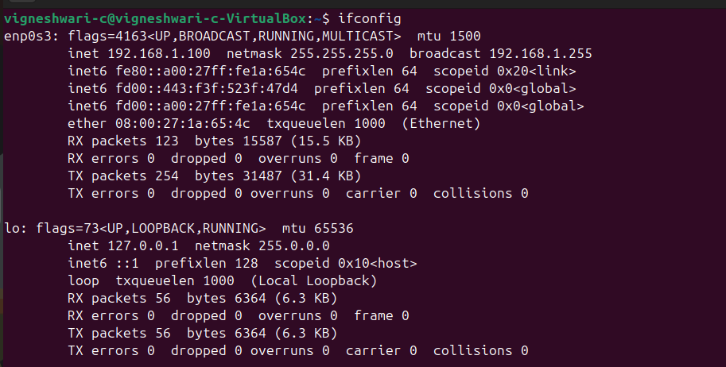

**Changing manually the ip:**

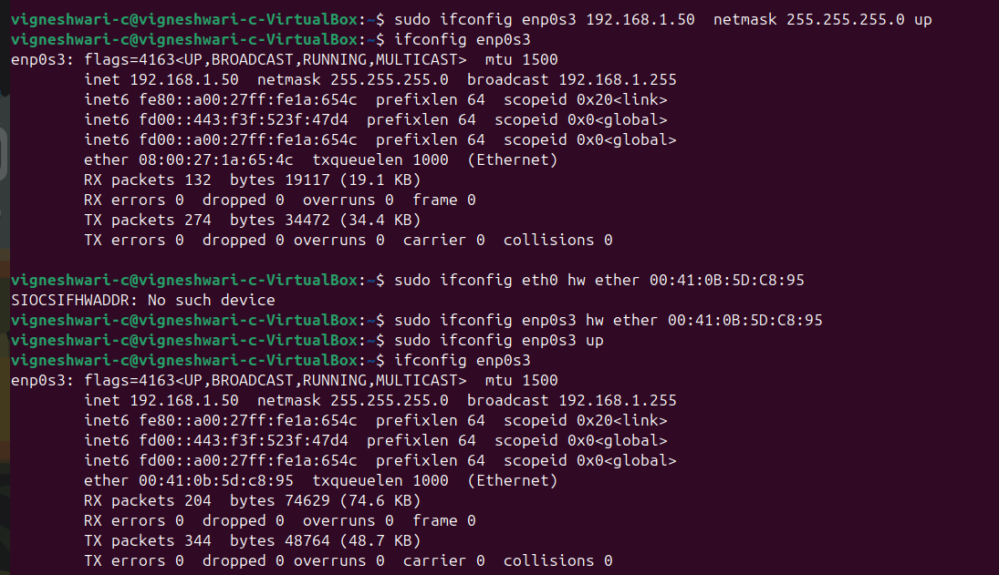

**Checking connectivity based on ping command:**

